Experiment 2
Setting Up a Network Using Different Cables

Lab 2 Objectives:
Understand the characteristics of different types of network cables (Coaxial, Twisted Pair, Fiber Optic).
Prerequisites: The prerequisites of this lab are-
● Basic knowledge of networking concepts and hardware.
● Understanding of data transmission and signal properties.
● Familiarity with network setup and configuration.

Outcomes: By the end of this lab, students will be able to:
● Identify and understand the properties of different network cables.
● Successfully set up a network using Coaxial, Twisted Pair, and Fiber Optic cables.
● Measure and analyze the performance of each cable type.
● Compare advantages and disadvantages based on experimental data.

Description: In this experiment, students will explore different types of network cables: Coaxial, Twisted Pair, and Fiber Optic to understand their characteristics and analyze their performance in real-world networking scenarios.

Understanding Network Cables

1. Coaxial Cable
Structure of Coaxial Cable
A coaxial cable consists of four main layers:
- Central Conductor:
  - Usually a copper wire that carries the electrical signals.
- Insulating Layer:
  - Surrounds the conductor to prevent signal loss and electrical contact.
- Metallic Shield:
  - Made of copper braid or foil, this layer protects the signal from external electromagnetic interference (EMI).
- Outer Jacket:
  - A protective plastic covering that shields the cable from physical damage.
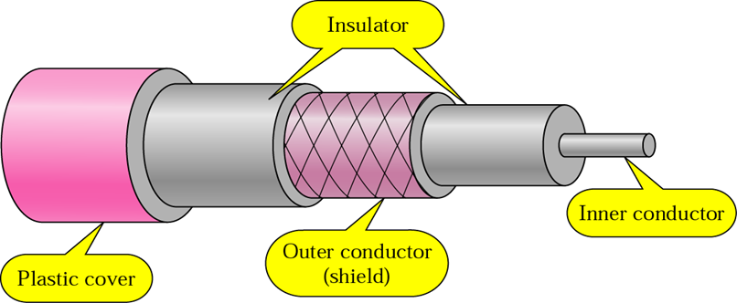

Uses
- Cable television (CATV) signal transmission
- Broadband internet connections
- CCTV and video surveillance systems
- Older telephone networks
Advantages
Excellent shielding protects against EMI and noise interference.
Higher bandwidth than twisted pair cables.
Durable and supports medium-distance transmission with less signal loss.
Low signal leakage ensures reliable communication.

Limitations
Bulkier and less flexible, making installation more difficult.
More expensive than twisted pair cables.
Slower speeds and lower bandwidth compared to fiber optic cables.
Signal degrades over long distances, requiring repeaters for extended ranges.
2. Twisted Pair Cable

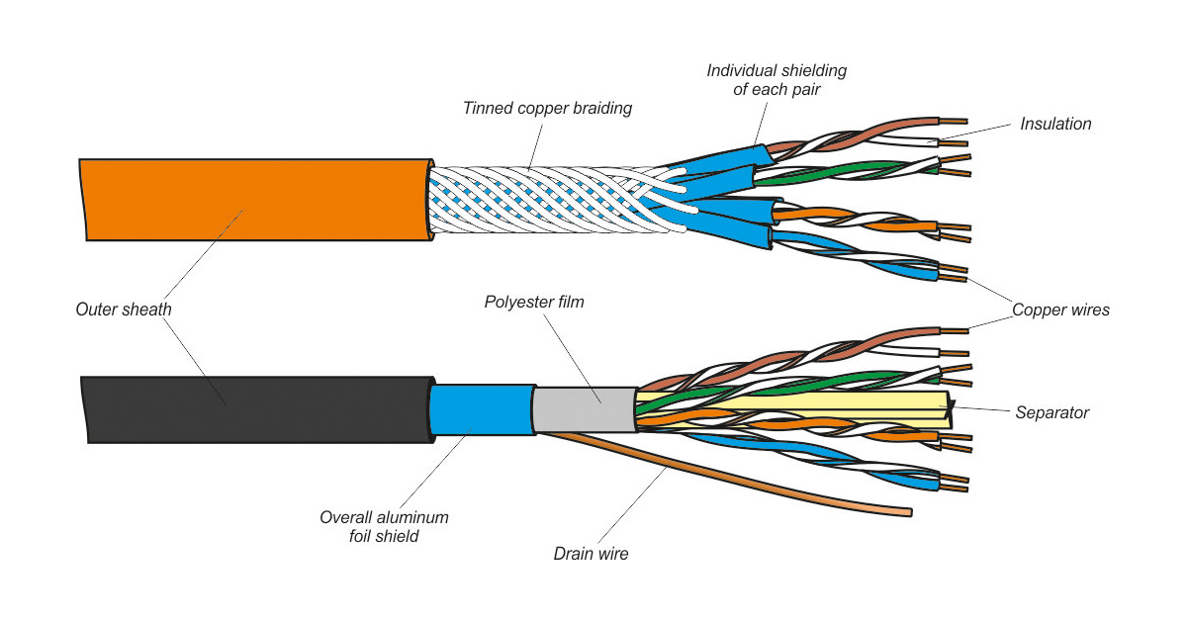

Structure
Twisted pair cables consist of pairs of insulated copper wires twisted together. The twisting helps reduce electromagnetic interference (EMI) from external sources and between pairs.
Categories
- CAT5e (Category 5e):
  - Enhanced version of CAT5. Supports speeds up to 1 Gbps over 100 meters.
- CAT6:
  - Improved shielding and tighter twists. Supports up to 10 Gbps (at shorter distances).
- CAT7:
  - Individually shielded pairs and overall shielding. Supports very high speeds, ideal for high-performance networking.

Uses
- Local Area Networks (LANs)
- Telephone line communication
- Ethernet cables in homes and offices
- Internet routers and switches

Advantages
- Lightweight, flexible, and easy to install
- Cost-effective compared to coaxial and fiber optic
- Good speed support, especially in CAT6 and CAT7
- Widely available and standardized

Limitations
- Susceptible to electromagnetic interference (especially in unshielded cables)
- Limited range — maximum cable length is about 100 meters
- Performance may drop over long distances without proper shielding
- Not ideal for very high-speed backbone networks

3. Fiber Optic Cable
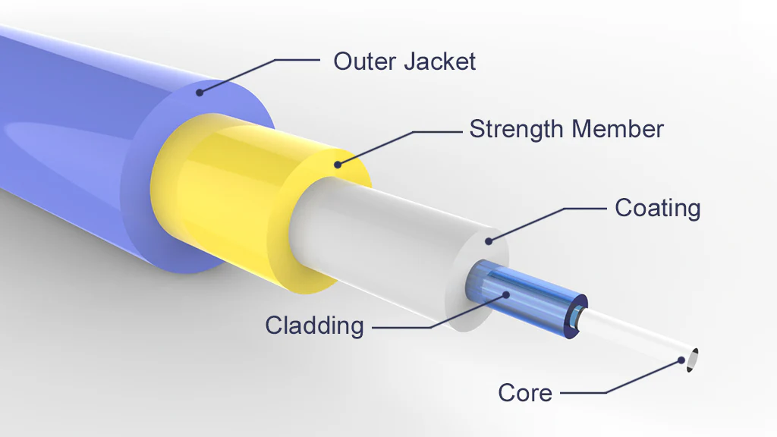
Structure
Fiber optic cables use glass or plastic fibers to transmit data as light signals, rather than electrical signals like copper cables.
They typically include:
Core: Thin glass strand where light travels.
Cladding: Surrounds the core and reflects light back into it.
Buffer Coating & Jacket: Protect the fiber from damage and moisture.

Types
- Single-Mode Fiber (SMF):
  - Very thin core (~9 microns)
  - Carries one light signal
  - Used for long-distance communication (up to 100 km+)
- Multi-Mode Fiber (MMF):
  - Thicker core (~50–62.5 microns)
  - Carries multiple light signals
  - Suitable for short-distance transmission (up to a few kilometers)

Uses
- High-speed internet and data backbone networks
- Long-distance telecommunications
- Data centers and enterprise networks
- Undersea cables and satellite communications

Advantages
- Extremely high bandwidth — supports very fast data rates
- Immune to electromagnetic interference (EMI)
- Secure transmission — hard to tap without detection
- Reliable over long distances with low signal loss

Limitations
- Expensive to install and maintain
- Fragile — glass fibers can break easily
- Requires specialized connectors and devices
- Complex handling and termination compared to copper cables

Setting Up the Network

Required Hardware (Assumed Setup)
For this experiment, we assume the following hardware components are available in a typical networking lab or virtual
environment:
Networking Devices:
- Network Switches
- Routers
- Personal Computers (PCs)
Cables:
- Coaxial Cable for legacy connections
- Twisted Pair Cable (CAT5e, CAT6) for LAN
- Fiber Optic Cable for high-speed data transmission
Testing Tools:
- LAN Testers (to check connectivity)
- Signal Analyzers (to test interference and quality)
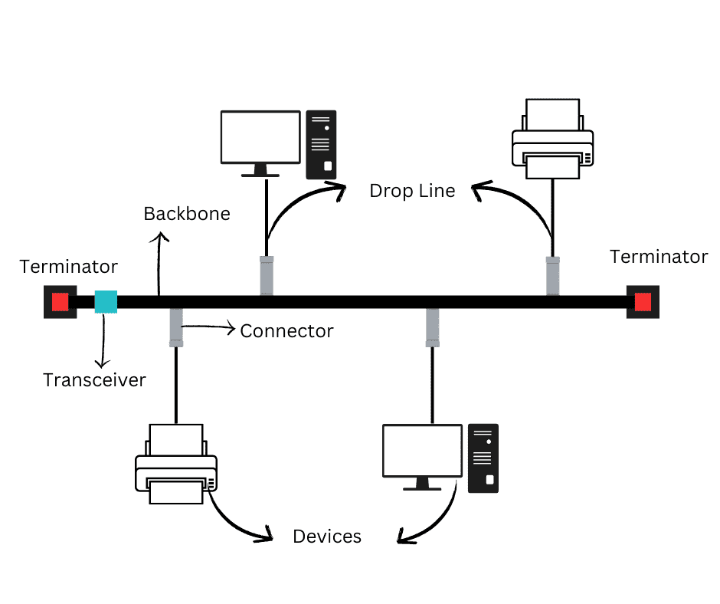
- Python-based tools like speedtest-cli for performance testing

Diagram:

Coaxial Cable

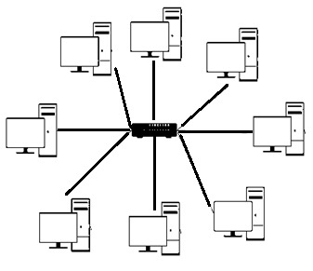
Diagram:

Twisted Pair Cable Network
Topology

Diagram:

Fiber Optic Cable Network Topology
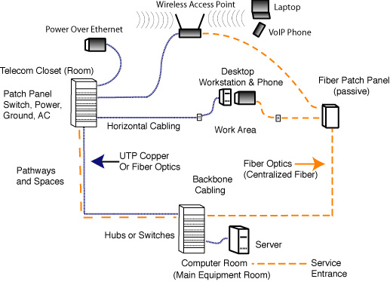

Network Configuration (Theoretical Steps)
Since physical setup wasn't possible due to hardware unavailability, the following steps are explained theoretically:

Step 1: Connect Devices with Each Cable Type
Devices like PCs and routers are connected separately using:
- Coaxial Cable (with BNC connectors)
- Twisted Pair Cable (with RJ-45 connectors)
- Fiber Optic Cable (with SC/LC connectors)
- For each setup, the connection is tested individually to observe behavior and performance.\

Step 2: Assign IP Addresses
Static IP Addressing:
Manually assign IP addresses like:
PC1: 192.168.1.2 / PC2: 192.168.1.3
Subnet Mask: 255.255.255.0

Dynamic IP Addressing:
DHCP server in router can automatically assign IP addresses to connected devices.

Step 3: Verify Connectivity
Ping Command => ping 192.168.1.3
Used to test connectivity between two devices.

Performance Analysis

Data Transmission Speed
Tools Used:
speedtest-cli (Python-based command-line speed testing tool)
iperf (For testing bandwidth between two devices on a network)

Process:
Each cable type (Coaxial, Twisted Pair, Fiber Optic) was theoretically tested for its maximum data transmission speed using speed test tools.

Cable Type | Observed Speed
Coaxial | 10–100 Mbps
Twisted Pair | 100 Mbps to 1 Gbps (CAT5e/CAT6)
Fiber Optic | 1 Gbps to 100 Gbps
Note: Fiber optic clearly outperforms in speed due to its light-based signal transmission and very high bandwidth.

Interference Resistance
Interference Sources Used (Theoretical):
- Nearby electric motors, fluorescent lights, microwave ovens, and mobile signals were considered for simulating interference.
Observations:
- Coaxial Cable: Moderate resistance due to shielding, but still vulnerable in high EMI areas.
- Twisted Pair Cable: UTP is highly susceptible to EMI; STP offers slightly better protection.
- Fiber Optic Cable: Immune to EMI as it uses light, not electricity.

Cable Type | EMI Resistance | Signal Stability
Coaxial | Medium | Fair
Twisted Pair | Low (UTP), Medium (STP) | Moderate
Fiber Optic | High | Excellent

Latency and Packet Loss
Tools Used:
- Ping command for latency measurement
- Wireshark / netstat / ifconfig (Linux) to monitor packet loss
Observations:
Cable Type | Average Latency | Packet Loss (Under Normal Conditions)
Coaxial | 20–30 ms | Low to Moderate
Twisted Pair | 5–10 ms | Low
Fiber Optic | <1–2 ms | Near Zero
- Coaxial: Slightly higher latency, especially over long distances.
- Twisted Pair: Good latency within 100m range, ideal for LAN.
- Fiber Optic: Lowest latency and almost zero packet loss — best for real-time applications like video conferencing, cloud gaming, etc.

